**Spike:**  *21*

**Title:** Measuring Performance

**Author:** Steven Efthimiadis, 1627406

**Goals / deliverables:**

Write a short report on measuring the performance of the Unreal Engine. Then create another short report on the performance difference between 100 dynamic verses 100 baked lights. Compare and report the difference.

To create this spike, you require:

* Use Spike 16 as a reference
* Performance measuring

**Technologies, Tools, and Resources used:**

List of information needed by someone trying to reproduce this work

* Performance Measuring
  + <https://docs.unrealengine.com/latest/INT/Engine/Performance/index.html>

**Tasks undertaken:**

* Open Spike 16 and the extra dynamic and baked lights
* Play the game and type the console commands for performance
* Write the report on Performance measuring
* Write the report for comparing dynamic and baked lights
* Create the blueprints

**What we found out:**

* You need to open the scene into a new window to type the commands in

**Open issues/ risks:**

* Sometimes because of all the lighting when you exit the scene unreal crashes because it’s trying to render all the lights.

# Performance Measuring

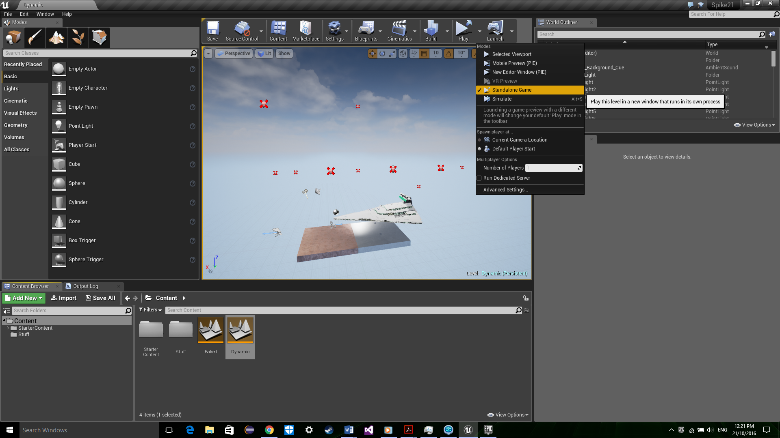 So you’re interested in measuring your performance of that great game you made? Well, firstly we need to open this epic scene. Now we need to open the scene in a new window by clicking the arrow next to launch and select a standalone game.

Now once the window is open you need to press the ~ key next to the 1 on the keyboard. Then the console will open and you can put all the commands in.

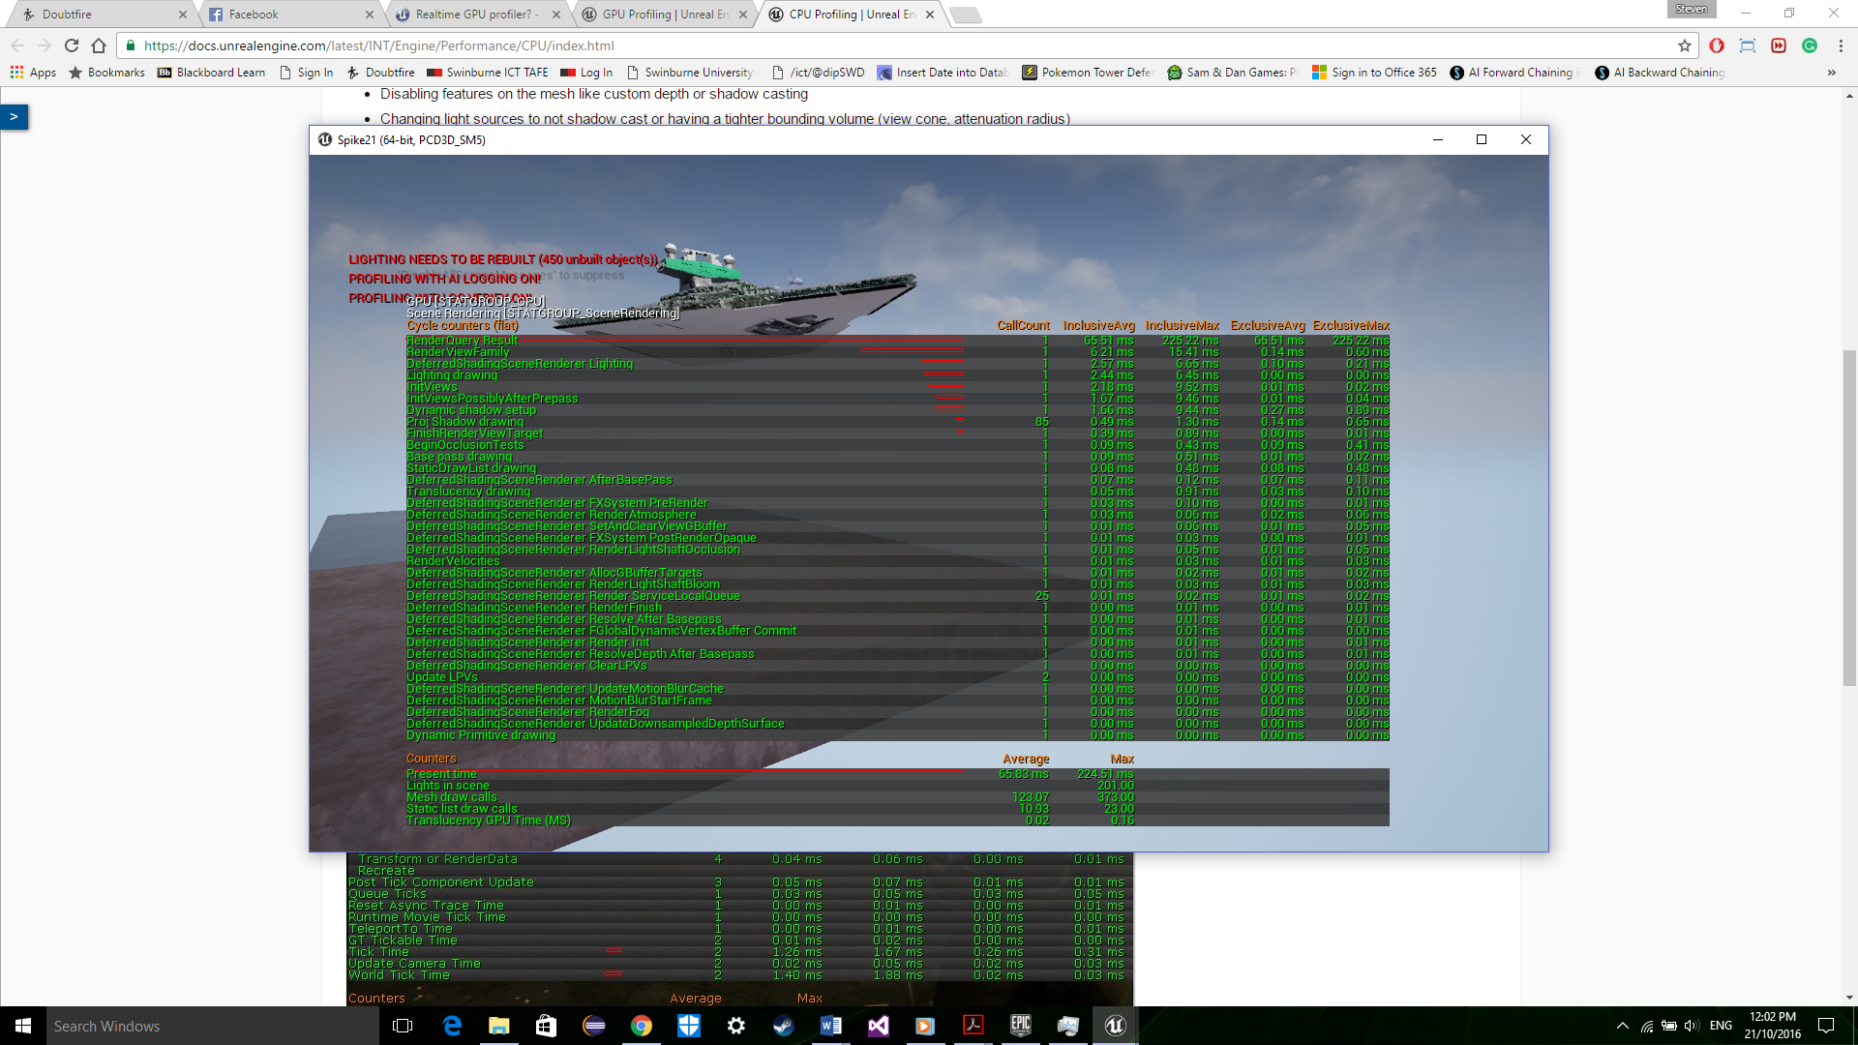

As you can see. By typing “stat ScenceRendering”, you can measure the rendering… judging by this. Your game is bad at rendering and you should feel bad…

Now you can all type “Stat Game” and it will display any attributes that apply to the running of the game

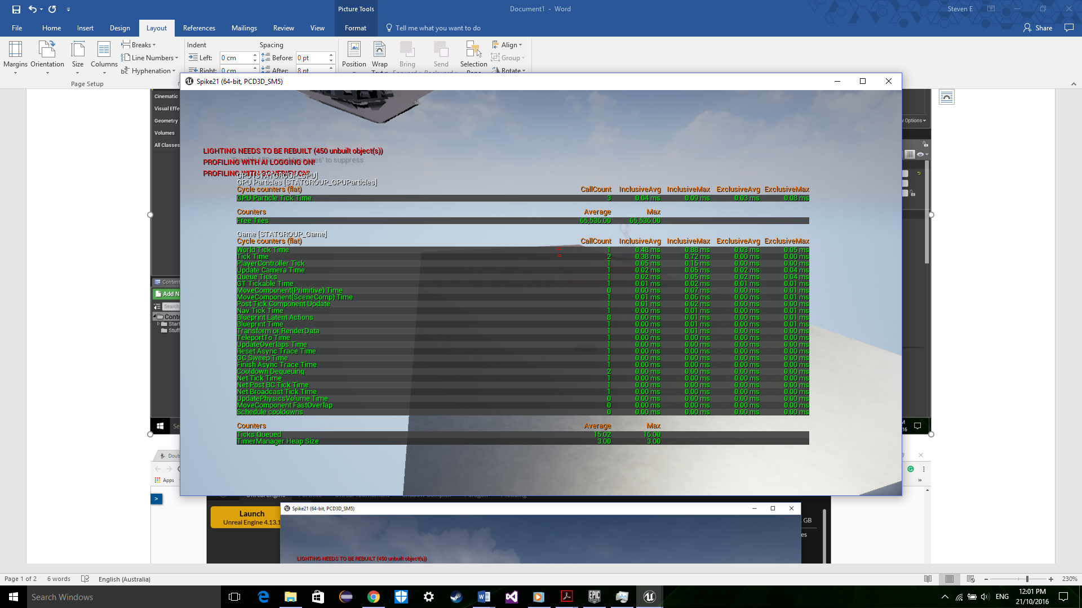

Now by looking at these you can see that in most stats your games is optimal. The only thing you need to work on is getting the time per tick (frame) lower. Now that you know you need to the rendering. You can update it before you showoff it to your friends.

# Dynamic V Backed Lights

Now you’re an expert in performance measuring. You have discovered that the problem is with your lighting you want to test the performance between the baked and dynamic lights. Now we need to see what type of light you’re using and test both.



So, as we see, you’re using dynamic lights so let's test them.

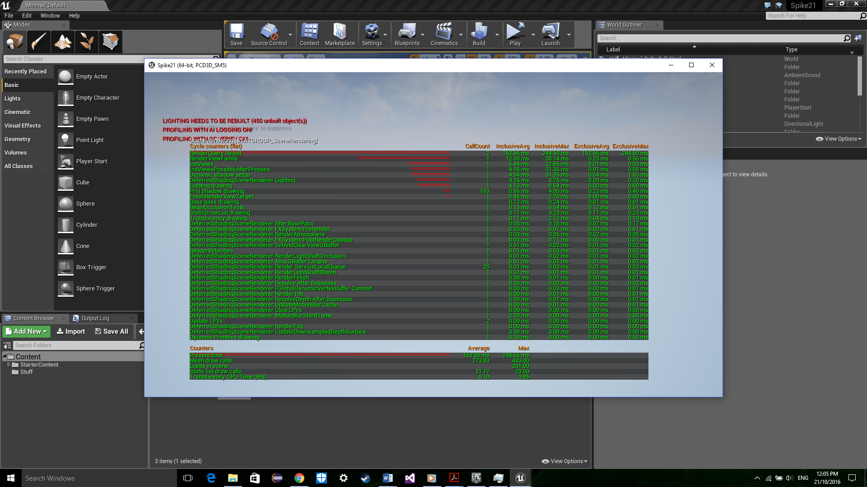

Oh, good there's your problem!!!!! It takes over 1.5 seconds to render your light per tick… So, let's see how long it takes per tick

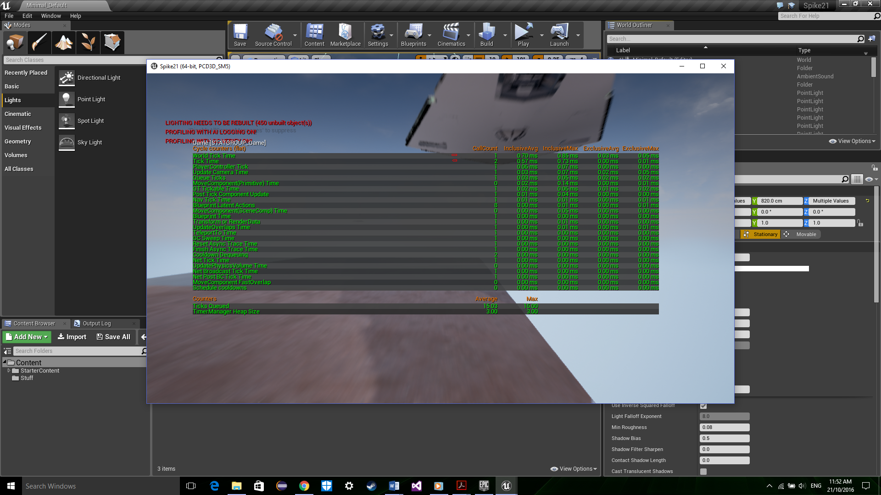My god it’s horrible… So, it takes over 1.5 seconds to render the light per tick… but each it is 0.7 seconds... so, if you do the math it takes 1.55 ticks to render the light for one tick… so we have discovered that baked lights are horrible for this game. Let's try Baked

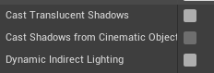Now we untick these options to create baked lights.

So, we are going to the same tests as the baked lights to compare the difference.



Oh, boy, this is much better but it’s still horrible. It’s a welcome improvement because it only takes. 0.65 seconds to render the lights instead of over 1.5 seconds.

Wow, now it only takes 0.48 seconds per tick. This is so much better but as you can see we need to improve the lighting still to match the tick.

Know we know that the dynamic lights are performing worst we need to learn why. Well, the main reason is that with the dynamic light, it adjusts to your position in the world. There will be a light direction which the source comes from. This source is like the sun so basically depending on your location and the surrounding. The game will cast shadow. So basically, this will increase the rendering time. But why doesn’t baked light do this? Well, they are basically the same as a dynamic light in which they reached to the light source, they are static. So, you could be running on the amount of light will be the same on all ticks. So naturally this will have a lower and stable rendering time. What is the best way to use dynamic and baked lighting? On your player’s camera, a dynamic light works well and baked lights around the world.